PRESS RELEASE

COMMUNICATIONS AND MEDIA TEAM OF THE 2023 ASEAN SUMMIT

No.50/SP/TKM-ASEAN2023/ENG/5/2023

Maximum Services at Sea Transportation During ASEAN Summit in Labuan Bajo

West Manggarai, 8 May 2023 – The Ministry of Transportation stated that all infrastructure is ready to provide best services to support the 42nd ASEAN 2023 Summit in Labuan Bajo, West Manggarai, East Nusa Tenggara from 9-11 May 2023, including in sea transportation.

Minister of Transportation Budi Karya Sumadi in Labuan Bajo Monday, 8 May, revealed that his ministry made several sea transportation arrangements to regulate the ships' movement in the Marina pier waters and around the Meruorah Hotel and Ayana Hotel, which became one of the venues for the ASEAN Summit.

Marina Harbor is set as the locatiuon for ASEAN leaders for sunset viewing over a Pinisi ship. In addition, a bazaar area, entertainment area, and bicycle facilities wil be provided for ASEAN Summit delegates around the port area. Minister of Transportation also ensured that the port condition was good.

"International events such as the ASEAN Summit teach us a lesson to continue to improve ourselves, especially in terms of service and cleanliness," said Budi.

To maintain water security and regulate the movement of Pinisi boats and Klotok boats (fishing boats) that usually pass in the area, Transportation Ministry deployed two patrol boats from the Directorate General of Sea Transportation's Sea and Coast Guard Unit (KPLP) from 5-12 May 2023.

"We will make proportional arrangements for fishing boats and Pinisi boats that usually pass through the location," said Budi.

The patrol boats deployed were the KPLP KN Chundamani P.116 Patrol Boat, which belong to the Class II PLP Base Tanjung Perak, and the KN Jembio belonging to Class I PLP Base Tanjung Priok. Each Patrol Boats are manned with 23 personnel, who are ready to maintain security and safety around these waters.

In addition, the Ministry of Transportation has assigned PT. Pelni to prepare the KM Sinabung with a capacity of 2,000 pax that will serve as floating accommodation for the accompanying team, national and foreign media, the security team, the executive committee, and other support teams at the Labuan Bajo Harbor Pier from 6-12 May 2023, free of charge.

The Ministry of Transportation also prepares port facilities and infrastructure to welcome ships docking at Labuan Bajo Port, such as KRI ships, hospital ships, and yachts. (Ministry of Transportation/TR/Elvira/WS/PPR)

***

For more information, please contact:

Director General of Public Information and Communications of the Ministry of Communications and Informatics - Usman Kansong (0816785320)

Get other information at http://asean2023.id, https://infopublik.id/kategori/asean-2023, and https://indonesia.go.id/kategori/ragam-asean-2023

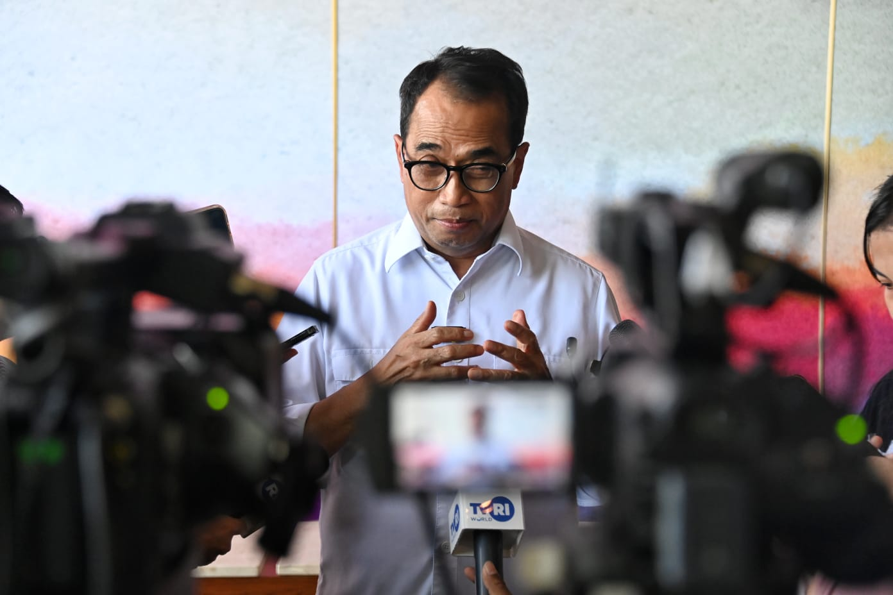

Minister of Transportation Budi Karya Sumadi in Labuan Bajo, Monday, 8 May 2023, revealed that his ministry made several sea transportation arrangements to regulate the ships' movement in the Marina pier waters and around the Meruorah Hotel and Ayana Hotel, which became one of the venues for the ASEAN Summit.

